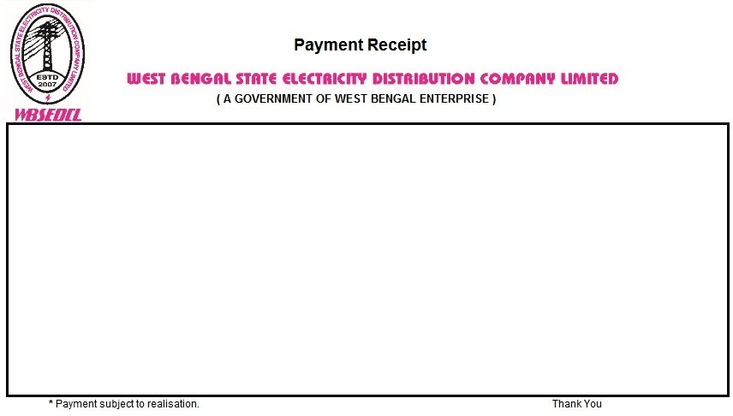

Transaction ID: YPHW2346365722 Date: 06.06.2024

Payment Gateway: BILLDESK

Billing Office: RANIGANJ CUSTOMER CARE CENTER

Consumer Id: 513076984 Name: RAJESH YADAV

Invoice Number /Appl. No. /Inst. No: 450013917798 Bill Paid For: JUN2024,JUL2024

Payment Mode : E-Payment Received: Rs. 3276